This is the title

P. LastNameª, P. LastName^{a,b}, P. LastName^{ab}
ªadress 1
^{b}adress 2

Key words: keyword1, keyword2, keyword3

1. Introduction

Example of bibliographic citations : [1],[2],[3]

2. A new section

An equation :

a² + b² = c² (1)

One cite a equation like this : eq. (1)

Table :

First | Second | Third
12 | 12 | 12
Table 1: Please write your table caption here

Figure :
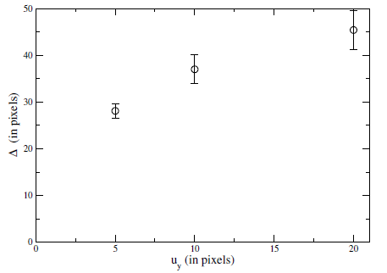
Figure 1: Please write your figure caption here

References

[1] Author4, Article title, Journal, Volume, page numbers (year)
[2] Author5, Article title, Journal, Volume, page numbers (year)
[3] Author6, Book title, page numbers. Publisher, place (year)

